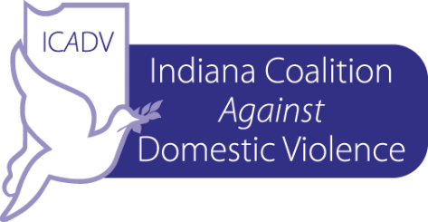
ICADV’s HOUSING LEGAL PROJECT

The Indiana Coalition Against Domestic Violence, Inc. contracts with attorneys all over Indiana to provide critical legal services to victims of domestic violence.
NEW
ICADV is now offering representation in housing cases, these include:

- Eviction Prevention
- Eviction Expungement
- Notices to cure
- Mediation plans, plans to vacate

Emergent cases are given priority, as are clients of limited means. Cases are referred to ICADV by our member programs which provide critical crisis and advocacy services to those survivors, promoting a holistic approach to survivor-focused cases.

For more information, contact ICADV Legal Counsel Kerry Hyatt Bennett at kbennett@icadvinc.org or 317-917-3685 or Legal Consultant Nupur Chandna at nchandna@icadvinc.org.

